

CSA0501-DATABASE MANAGEMENT SYSTEMS

LAB EXPERIMENTS DATE: 10/07/2026

EXPERIMENT 1 -- DDL Commands with Constraints – PRIMARY, FOREIGN KEY, UNIQUE, CHECK

AIM:
To add the constraints like primary key, foreign key, unique key and check using DDL commands.
PROCEDURE:
​Select the required database using the USE command.
​Create the pets_data table with required attributes (s_no, petsname, petBreed, age, food, place, total).
​Apply PRIMARY KEY constraint on s_no to uniquely identify each record.
​Apply UNIQUE constraint on petsname to avoid duplicate pet names.
​Apply CHECK constraint on total to maintain valid non-zero data.
​Create a secondary table place_details and establish a relationship using a FOREIGN KEY constraint.
​Verify the applied constraints using DESC and SHOW CREATE TABLE commands.
​Display the final table details and confirm successful execution.
PROGRAM

​1. TABLE
USE pets_db;

SELECT * FROM pets_data;

OUTPUT:
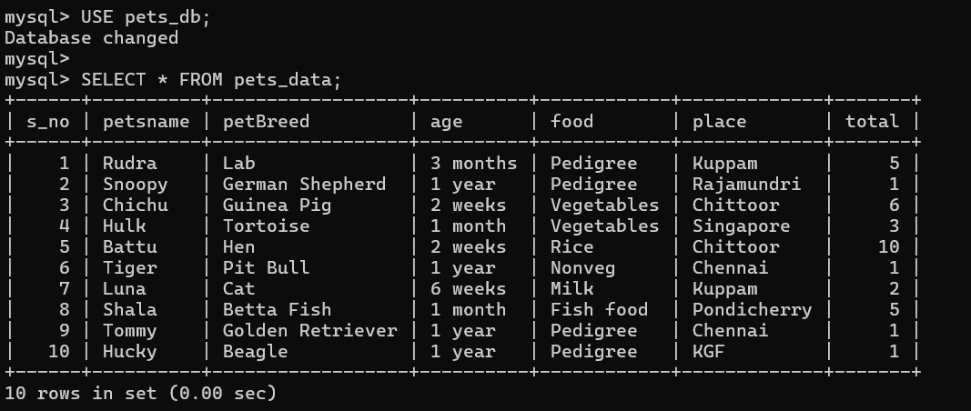

2.PRIMARY KEY
DESC pets_data;
ALTER TABLE pets_data
ADD PRIMARY KEY (s_no);

OUTPUT:
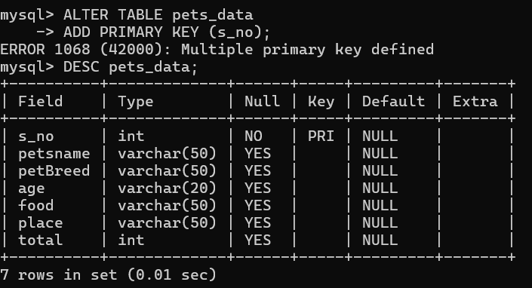

3.UNIQUE KEY
DESC pets_data;
ALTER TABLE pets_data
ADD CONSTRAINT unique_petsname
UNIQUE(petsname);

OUTPUT:
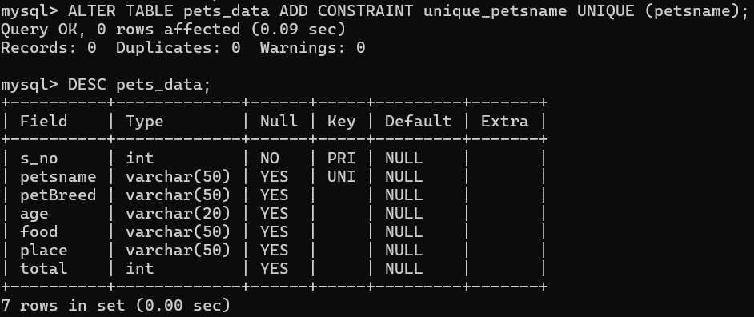

4.CHECK CONSTRAINT:
DESC pets_data;
ALTER TABLE pets_data
ADD CONSTRAINT chk_total
CHECK (total > 0);

OUTPUT:

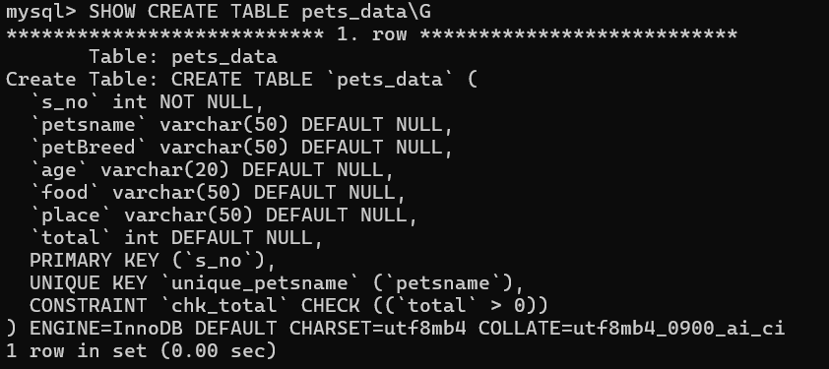

5.FOREIGN KEY CONSTRAINT:
ALTER TABLE pets_data
ADD CONSTRAINT fk_place
FOREIGN KEY (place)
REFERENCES place_details (place_name);

OUTPUT:
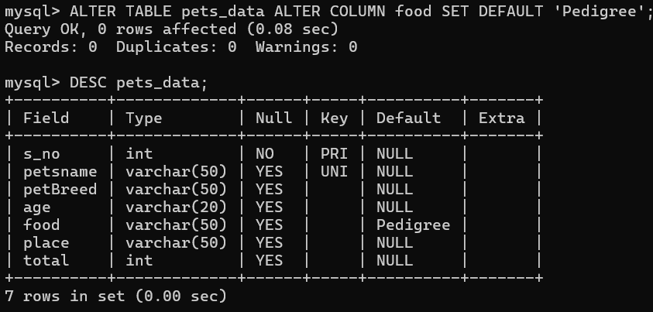

RESULT: DDL Commands with Primary, Foreign, Unique, Check constraints are updated and verified.

